
W-16
11 PHYSICS ATAR
TEST 5: WAVE MOTION

NAME: MARK: 

1. When a person in a room coughs, one or two of the lower notes of a piano in the same room are often heard to sound. Name the physical phenomenon of which this is an example and explain why only a few notes sound.

(2)

2. A tuning fork of frequency of 256 Hz gives four beats per second when sounded with a second tuning fork. When a piece of plasticine is attached to the first fork, the number of beats increases to five per second.

What is the frequency of the second fork? Show some working to justify your answer.

(3)

3. A light string of length 3.00 m in is fixed at one end in a Science laboratory. A wave is generated through it by an oscillating arm fixed to a remodelled speaker operating at a frequency of 125 Hz. A wave pattern was produced and maintained with five nodal points that appeared stationary, not including the endpoints.

(a) What type of wave pattern is being produced?

(1)

(b) What conditions are necessary for this to occur?

(2)

(c) Which harmonic is the string showing? Draw a diagram to show it.

(2)

(d) Determine the wavelength of the waves produced.

(2)

(e) Determine the speed of the wave in the string.

(2)
4. A Physics class was shown the effect of walking across the room in a straight line at right angles to two speakers that were sending out a 500 Hz note. As the students moved along the line, it became quite evident that there are alternating "loud" and "soft" spots occurring.

(a) Use the diagram below to help explain why this phenomenon occurs.
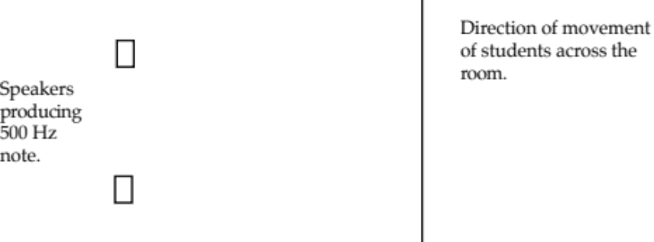

(3)

(b)
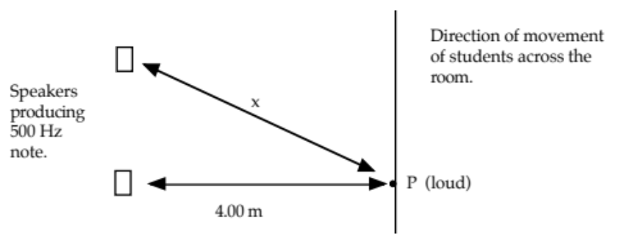

At point P, a student hears a loud sound. What is the minimum length of the
distance x?

(3)
5. A sound wave moving at 3.40 x 10² ms⁻¹ in air is represented below.

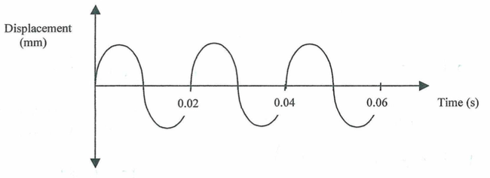

(a) Determine the period of the wave.

(1)

(b) Determine the frequency.

(2)

(c) What is the wavelength of the wave?

(2)

6. During a concert at the Perth concert Hall, a flute player produced a pure note that caused the 45.0 cm air column to resonate at its second harmonic. Assume that the flute acts as an open air column and that the air temperature is 25 °C.

(a) Draw a diagram to show the flute resonating at its second harmonic.

(2)

(b) Calculate the frequency that the flute is producing.

(4)

(c) What is the fundamental frequency of the flute?

(1)

